InceptionFlora: Revolutionizing Plant Species Identification with AI and Deep Learning

Tamilarasi Kathirvel Murugan1*, Pavithra Sekar1, Khushi Tolani1,Ashna Sachdeva2, Shradha Suman Jena2 and Aditya Kumar Jha2

1,2School of Computer Science & Engineering

Vellore Institute of Technology, Chennai Campus, Tamil Nadu, India.

[Tamilarasi.k@vit.ac.in](mailto:Tamilarasi.k@vit.ac.in)

[Pavithra.sekar@vit.ac.in](mailto:Pavithra.sekar@vit.ac.in)

khushi.tolani2021@vitstudent.ac.in   
ashna.sachdeva2021@vitstudent.ac.in

shradhasuman.jena2021@vitstudent.ac.in   
[adityakumar.jha2021b@vitstudent.ac.in](mailto:adityakumar.jha2021b@vitstudent.ac.in)

**Abstract.** This research suggests a multi-layered approach to plant species

classification by making use of the general Deep Learning paradigm in addition to selective Machine Learning techniques. A method is suggested which may be precipitated by the deep Convolutional Neural Networks method called

InceptionV3 for feature extraction from the pictures of plants. Using the

transfer learning, the InceptionV3 model trained before is then used for   
determining the species level of a plant image. On hand, extra layers of   
customization are executed atop the features to train the species classification. Furthermore, the incorporation of well-known supervised machine learning   
algorithms which are Support Vector Machine and k-Nearest Neighbors as   
supplemented approaches for deep learning is realized. To evaluate the   
proposed method, an image set of plants is used to test the performance with the help of different evaluation metrics. In overall, the proposed approach exhibits a possibility to classify the species accurately and combines in itself good results of deep

learning as well as artificial intelligence techniques for the task assigned.

**Keywords:** Convolutional Neural Networks, k-Nearest Neighbors,

InceptionV3, Support Vector Machine, Artificial Intelligence, plant species

1 Introduction

### Identifying plant species used to be a job that needed lots of know-how and took a long time. This project gives us a quick fix by using machine learning (ML) and artificial intelligence (AI) tech deep learning and computer vision. Systems that work on their own can sort plant pictures without people helping using big sets of images like ImageNet and PlantCLEF. These systems get pretty good results when these CNN methods such as AlexNet, VGG, ResNet, and Inception are used. The system that is built uses the InceptionV3 model to extract features. It relies on pre-trained weights from ImageNet to classify plant species. The system has several parts: it prepares data, makes more varied images, pulls out features with InceptionV3, sorts plants into species, and works with other ML methods. Getting the data ready and making more images helps the model learn better. InceptionV3 finds important parts of each image. Then special layers sort these parts into different plant types. As the model is trained, it doesn't just memorize the training data but can work well with new images. Traditional ML methods like SVM and KNN on the features from InceptionV3 are also used. This mixes new deep learning ideas with tried-and-true ways to figure out plant species. The system made is easy to identify plants and form pictures. It's useful for farming studying nature, plant research, and protecting wildlife. In this paper, it is shown that how the system works and how AI and ML is combined, what the results mean, and what are the future enhancements.

**2 Literature Review**

Siddharth et al. (2022) proposed a study on the detection of plant diseases using CNNs, indicates the prospective of this field and the requirement of further better approaches. Leveraging on CNNs’ applicability in image identity programs, crop yield estimation, and disease diagnostics for sustainable plant breeding and heritage is something that has been highlighted by the article.[1] Zefri et al. (2022) intended to investigate the capability of Convolutional Neural Networks in image recognition and classification and the flexibility and robustness of the Convolutional Neural Networks that contributed to improving the authors proposed system in agriculture, ecology, and the environment [2]. Ghosh et al. (2023) presented a paper that discusses the employment of Support Vector Machines (SVM) as well as KNN-based CNNs in plant classification with especial stress on feature extraction, classification performance as well as model interpretability [3]. Lee et al. (2023) proposed a paper on "Plant-CNN-ViT: In the research titled “An Ensemble of Convolutional Neural Networks and Vision Transformers for Plant Classification”, the reader is presented with a new way of

classifying plants that uses more than one model to give better prediction accuracy and reliability [4]. Rashid et al. (2023) proposed a paper that reviews the old research works, deep learning Convolutional and Recurrent Neural Networks and integrates them with conventional machine learning techniques for developing plant classification classifiers [5]. Sothe et al. (2020) introduced a study that is devoted to the comparison of Convolutional Neural Networks, Support Vector Machines, and Random Forest Classifier for plant species identification based on hyper spectral and photogrammetric data and cover questions related to spectral variability and robust feature extraction [6]. Chan et al. (2015) have used the CNN for plant identification focusing on the benefits of CNN in terms of images and their sorting; the configuration of the CNN structure elucidated by the authors together with the application of the CNN in agriculture, ecology, and conservation biology [7]. Bambil et al. (2020) used color learning, machine learning, and artificial neural networks in a multiple step approach for detecting plant species. It has surveyed previous works, image processing, computer vision, pattern recognition, and virtual reality applications [8].

Toth et al. (2016) claimed a paper that gives an overview of deep learning and SVM   
classification for plant species detection from the huge image dataset and future   
applications in the field of Biodiversity Conservation, Agriculture, and Ecological Supervision [9]. Hassan et al. (2022) proposed a paper “Plant Disease Identification Using a Novel Convolutional Neural Network”, which explains the application of CNN in plant disease identification stating the advantages of this approach in agricultural and plant pathology fields [10].

The proposed methodology refines categorical classification systems that are being used for plant species by incorporating deep learning techniques like, CNNs and another strategy called ensemble technique. Sometimes it has a hierarchical structure which is even more suitable for the classification problem as it performs feature   
extraction too. The advantages of the ensemble approach stem from the use of   
multiple models that result in higher accuracy as well as the refinement of the image in different circumstances. This will help in easy and fast identification of the plant species in question through the use of the intended approach.

**3 Proposed Methodology**

The identification of the plant species is proposed by the merge of deep learning with the more classical approaches, in which InceptionV3 network is adopted as the feature extractor and not as classifier. Further, the images are pre-processed for InceptionV3, which extracts basic plant morphology patterns, followed by layers of custom plant classification with the help of Global Average Pooling and fully connected layers with ReLU activation. The result of SoftMax layer estimates the likelihood of the category of plant. When training the final classification layers, the convolution layers of the network are frozen together with transfer learning on hand-tagged images. The procedure called backpropagation works through epochs and improves the model’s dependability in the network. Further, basic models like SVM and KNN are used on the feature matrix obtained from InceptionV3. Operations such as resizing, rotating and flipping help to make the model general. This utilized model again demonstrates an improved accuracy, precision, recall, and F1-score for classifying the known and unknown plant species.

**3.1 DeepCNN Feature Extraction:**

The results of each layer in a DeepCNN (InceptionV3) is calculated using the   
convolution process and activation function such as ReLU (Rectified Linear Unit):

Convolution Operation is represented in Equation 1 as -

(l)zi= ∑j (l)Wij* (l-1)xj+ (l)bi (1)

Activation Function(ReLU) is represented in Equation 2 as -

(l)ai= ReLU((l)zi) = max(0, (l)zi) (2)

Pooling Operation is represented in Equation 3 as -

(l)yi = max((l)xj) (3)

Here, (l)zi represents the result of neuron i in layer l, (l-1)xj is the input from the   
previous layer, (l)Wijrepresents the weights joining neuron j in layer l-1 to neuron i in layer l, and (l)bi is the bias term.

## 3.2 Training:

Cross-entropy loss is commonly used in CNN training for multi-class classification is represented in Equation 4 as -

Loss = -1/N(NΣi=1CΣj=1yij log(pij))  (4)

Where N is the number of samples, C' indicates the number of classes, yij is the   
function (If sample i is a member of class j, then it is 1; otherwise, it is 0), and pij​represents the predicted probability that sample i belongs to class j.

Gradient Descent Update Rule is represented in Equation 5 as -

θ(t+1) = θ(t) - ƞ∇θLoss (5)

Here this equation shows the fine tuning process where, θ(t+1) denotes the updated   
parameter values at time *t*+1, while θ(t) signifies the current parameter values at time *t*. The learning rate is denoted by *η*, controls the step size of parameters. The   
expression∇𝜃Loss expresses the gradient of a loss function with respect to the parameters θ, showing the direction and magnitude of the steepest increase in the loss function.

## 3.3 SVM Classification:

In SVM, the decision function for classification can be shown in Equation 6 -

f(x) = sign(nΣi=1 αiyi K (x, xi) + b) (6)

Where xi represents the support vectors, yi denotes the corresponding class labels, αiare the Lagrange multipliers obtained during training, K (x, xi) is the kernel function measuring the similarity between x and xi, and b is the bias term.

Kernel Function (linear) is shown in Equation 7 as -

K(x,xi) = xTxi (7)

Here, *x* and xi are input vectors, which represents feature vectors of two data points and xTrepresents the transpose of vector *x.*

## 3.4 Evaluation Metrics:

Accuracy is represented in Equation 8 as -

Accuracy = (8)

Precision is represented in Equation 9 as -

Precision = (9)

Recall is represented in Equation 10 as -

Recall = (10)

F1-score is represented in Equation 11 as -

F1-score = 2 × (11)

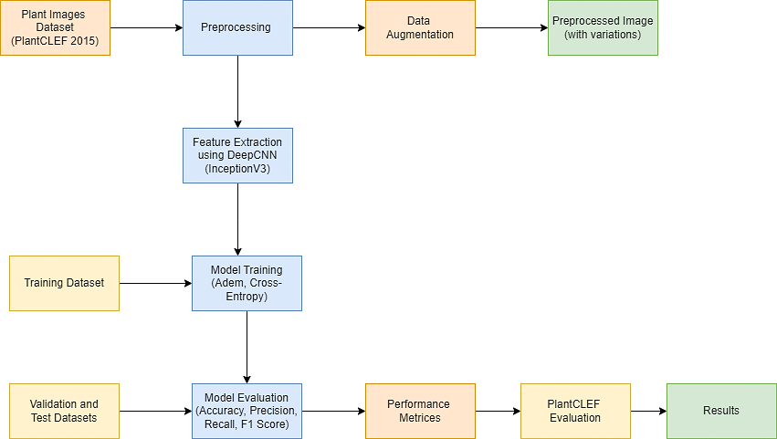

**Fig.1.System Architecture**

Fig 1 depicts a parallel architecture of plant identification system where the input is processed with deep convolutional neural networks like InceptionV3 and then, SVMs feature sets are supplied for classification, respectively.

**Algorithm: IncepSpecClassifier**

*Input:*PlantCLEF 2015 Dataset

*Output:*Predicted labels for plant species and trained model for plant species   
identification.

***Start***

*Load the dataset*

Load Class Names

Open and read class names from labels.txt

*Define Image Dimensions*

img_height, img_width<- 299, 299

batch_size<- 16

epochs<- 5

*Data Preprocessing and Augmentation*

Initialize ImageDataGenerator for training with augmentation

Initialize ImageDataGenerator for validation and test without augmentation

*Load Data Using Generators*

train_data_gen<- flow_from_directory(train_dir, target_size=(img_height, img_width), batch_size=batch_size, class_mode='categorical', shuffle=True)

val_data_gen<- flow_from_directory(val_dir, target_size=(img_height, img_width), batch_size=batch_size, class_mode='categorical', shuffle=False)

*Load InceptionV3 Model with Pre-trained Weights*

base_model<- InceptionV3(weights='imagenet', include_top=False,   
input_shape=(img_height, img_width, 3))

Add custom classification layers on top of the base model

Freeze base layers

*Compile and train the Model*

Compile the model with Adam optimizer, categorical_crossentropy loss, and   
accuracy metric

Train the model with train_data_gen, validate with val_data_gen, for specified epochs

*Evaluate the Model on Validation Set*

Evaluate the model and print validation accuracy

*Load and Predict on Test Set*

Initialize test_data_gen without labels

Predict on test set using the model

Load and preprocess images, make predictions, and store results

*Display Predictions*

Display filenames and corresponding predicted labels

Plot the predictions for test images with class names

*Calculate Evaluation Metrics*

Calculate accuracy, precision, recall, F1-score for predictions

Print Evaluation Metrics and Confusion Matrix

*Extract Features Using Trained CNN*

Extract features from train and validation datasets using the trained model

*Train and Evaluate SVM Classifier*

Train SVM classifier on extracted features and evaluate on validation set

*Train and Evaluate KNN Classifier*

Train KNN classifier on extracted features and evaluate on validation set

***End***

# 4 Results and Discussions

InceptionV3 model outperformed normal machine learning algorithms for plant   
species identification, achieving 84.6% total accuracy in real-raw images based on flow and structural information.

This model is capable of distinguishing plant species with raw image features; classes such as dandelion, dogwood, and elm were well handled although some classes proved a bit difficult to handle. The confusion matrix pointed out some of the issues that need to be addressed. Although, InceptionV3 – relies on deep learning and seems to work better with complicated image patterns though the usage of a large amount of computational recourses and overfitting in cases with small datasets. Optimizations which can be applied in the future are hyperparameter optimization, changing the architecture type and increasing the data augmentation to enhance generalizability. Combining deep learning with traditional methods can improve the results; therefore, InceptionV3 becomes a valuable instrument in the identification of plant species, their protection, agriculture, and in ecological surveys.

**Table 1.** Customer Layer Classification of Inception V3 Model

|  |  |  |  |
| --- | --- | --- | --- |
| Layer (type) | Output Shape | Param # | Connected to |
| Input_1 (InputLayer) | [(None, 299,299, 3)] | 0 | [ ] |
| Conv2d (Conv2D) | (None, 149, 149, 32) | 864 | [‘input_1[0][0]’] |
| Batch_normalization (Batch normalization) | (None, 149, 149, 32) | 96 | [‘conv2d[0][0]’] |
| Activation (Activation) | (None, 149, 149, 32) | 0 | [‘batch_normalization [0][0]’] |
| Conv2d_1 (Conv2D) | (None, 147, 147, 32) | 9216 | [‘activation[0][0]’] |
| Batch_normalization_1 (Batch normalization) | (None, 147, 147, 32) | 96 | [‘conv2d_1[0][0]’] |
| Activation_1 (Activation) | (None, 147, 147, 32) | 0 | [‘batch_normalization_1[0][0]’] |
| Conv2d_2 (Conv2D) | (None, 147, 147, 64) | 18432 | [‘activation_1[0][0]’] |
| Batch_normalization_2 (Batch normalization) | (None, 147, 147, 64) | 192 | [‘conv2d_2[0][0]’] |

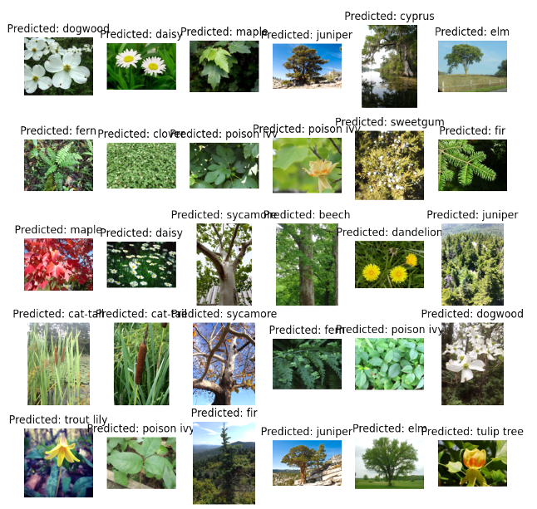

**Fig.2. Predicted Output**Fig 2 depicts error indicators of the model which were predicted on the test pictures. In each case the title for the subplot shows the class as predicted by the model in this way.

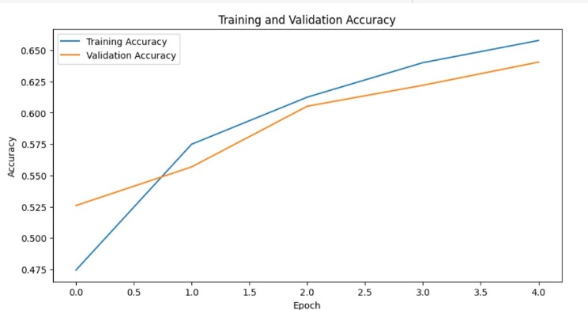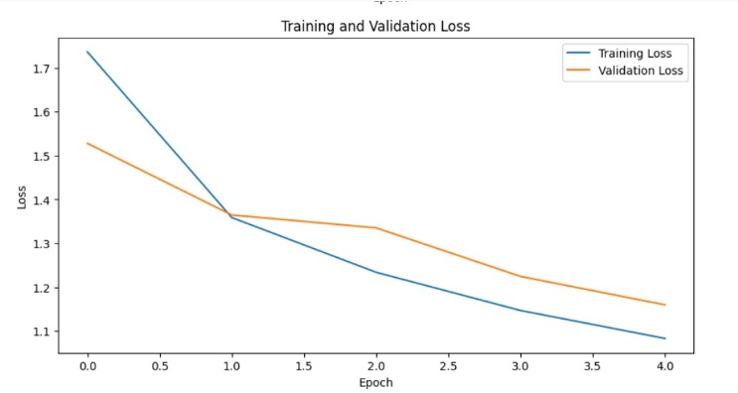

**Fig.3. Accuracy Graph Fig. 4. Loss Graph**

Fig 3 illustrates the precision curve for both data sets traversing the direction of   
training as it switches, whereas Fig 4 depicts a line graph drawing the difference in the training and validation loss vs. epochs during model training.

# 

**Fig.5.Confusion Matrix**  
Fig 5 represents the confusion matrix, where each cell describes how many of the model's predictions the model has made. The horizontal axis, x-axis, indicates   
predicted labels whereas the vertical axis, y-axis, displays actual observed true values.

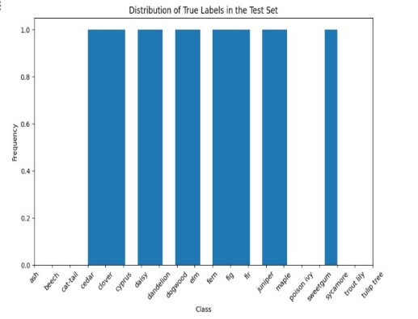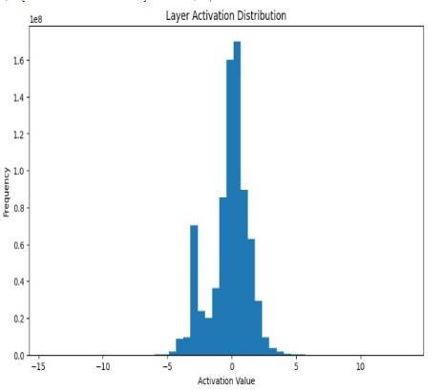

**Fig. 6. Class Frequency Graph Fig. 7. Layer Activation Graph**Fig 6 shows the distribution of true labels on test set amongst various categories,   
whereas Fig 7 shows that the activations from the hidden layer that constitute the neural network model.

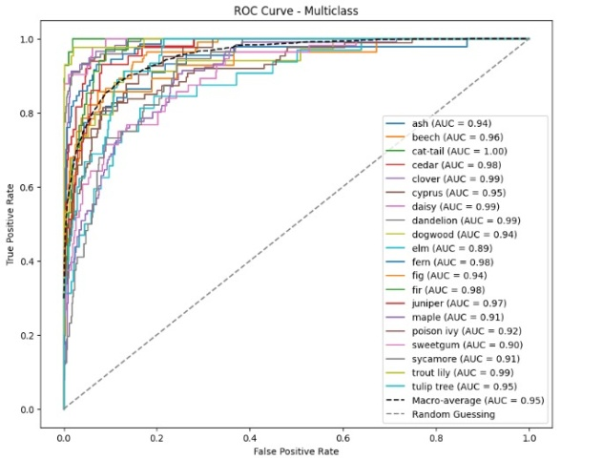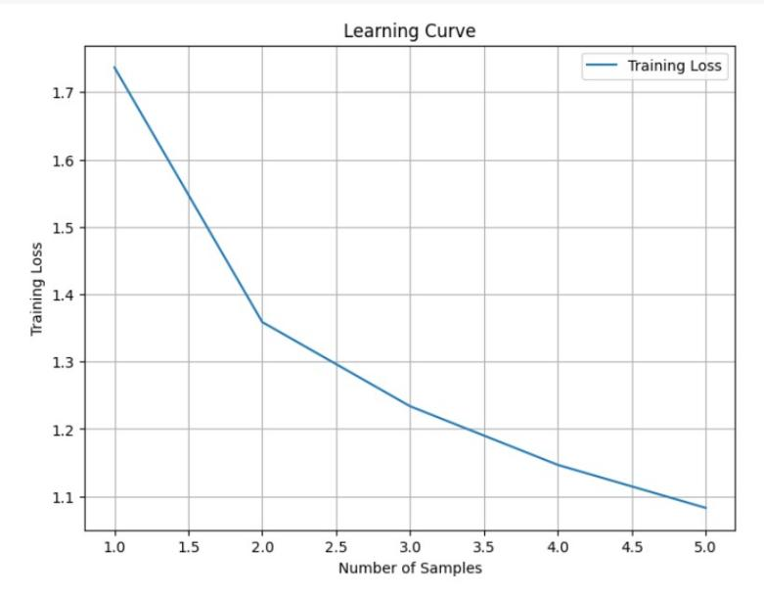

**Fig. 8. ROC-AUC Curve Fig. 9. Learning Curve**

Fig 8 represents the ROC curve and used in the multiclass case to examine the   
classifier of each class, whereas Fig 9 shows the form of a learning curve, in which the behavior of the training loss is presented.

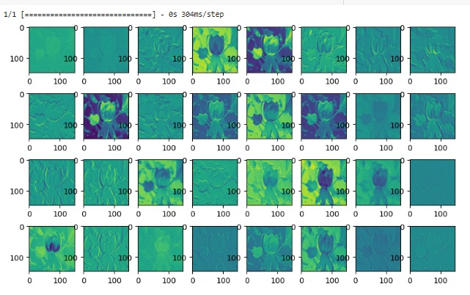

**Fig. 10.Activation map**

Fig 10 depicts the outputs that the neural network model creates for this picture,   
showing the intermediate layer extracting the feature maps. These channels display the functional activation maps which are related to specific feature channels.

**5 Conclusion**

Finally, the specified plant species recognition system emphasizes the advantages of the combination of deep learning and traditional algorithms of machine learning. With the help of pre-trained and trained InceptionV3 for high-level visual descriptor feature extraction and transfer learning, the model is able to extract efficiently visual   
blueprints from plant images. Customize the classifier by applying the SoftMax  
activation to calculate the features and finally translate them to probabilities for   
different the plant species. Employing this technique keeps the model progressed on the specific task of plant identification, while the InceptionV3 architecture remains unaltered. The performance is assessed by the systems metrics such as accuracy,   
precision, recall, and F1-score. The choice is either to introduce traditional algorithms like SVM and KNN so that they can combine their strengths and maybe improve the whole recognition accuracy level. This conjunction of the world of deep learning and conventional machine learning is a candidate for creation of gapless and correct plant identification systems.

**6 Future Enhancements**

In the proposed system improvement plans, performance, efficiency, and usability are expected to be improved by increasing data acquisition, the use of ensembles and   
multi-model predictions, and for transfer learning using fine-tuning from pre-trained models. Live deployment for Mobile as well as for the Embedded devices is likely to improve practicality and usability. On the same note, a smooth user interface will   
attract users from agriculture, biodiversity, and the whole concept of environmental conservation. Innovation and enhancements are crucial due to many needs from   
different sectors.

**7 Limitations**

Traditional methodologies used in plant species identification such as CNNs and SVMs encounter some challenges including; in representation, and random datasets, and reduced capability to respond to other species and environment, making them bias. The quality of the training data is critical to the system’s performance, and the   
calculations performed make the approach non-transparent and hard to trust.   
Considering lighting and occlusion as the influencing variables, identification accuracy loses its high rate. Limitations include issues with data quality, tuning of the algorithms used for modeling, and differences in users’ knowledge. Advanced improvements have to be backed up by better instructions for users, people’s feedback as well as constant investigations and developments.

8 References

1. S. Siddharth, B. S. Kirar, and D. K. Agrawal, "Plant species classification using transfer learning by pretrained classifier VGG-19," *IETE Journal of Research*, 2022, doi: 10.48550/arXiv.2209.03076.

2. W. M. A. H. B. W. Zefri and S. Nordin, "Plant recognition system using convolutional neural network," *IOP Conference Series: Earth and Environmental Science*, vol. 1019, no. 1, p. 012031, 2022, doi: 10.1088/1755-1315/1019/1/012031.

3. S. Ghosh, A. Singh, Kavita, N. Z. Jhanjhi, M. Masud, and S. Aljahdali, "SVM and KNN based CNN architectures for plant classification," *Computers, Materials & Continua*, 2022, doi: 10.32604/cmc.2022.023414.

4. C. P. Lee, K. M. Lim, Y. X. Song, and A. Alqahtani, "Plant-CNN-ViT: Plant classification with ensemble of convolutional neural networks and vision transformer," *Plants*, vol. 12, no. 14, p. 2642, 2023, doi: 10.3390/plants12142642.

5. J. Rashid, I. Khan, I. A. Abbasi, M. R. Saeed, M. Saddique, and M. Abbas, "A hybrid deep learning approach to classify the plant leaf species," *Computers, Materials & Continua*, 2023, doi: 10.32604/cmc.2023.040356.

6. C. Sothe *et al.*, "Comparative performance of convolutional neural network, weighted and conventional support vector machine and random forest for classifying tree species using hyperspectral and photogrammetric data," *GIScience & Remote Sensing*, vol. 57, no. 3, pp. 369-394, 2020, doi: 10.1080/15481603.2020.1712102.

7. S. H. Lee, C. S. Chan, P. Wilkin, and P. Remagnino, "Deep-Plant: Plant identification with convolutional neural networks," *arXiv preprint arXiv:1506.08425*, 2015.

8. D. Bambil *et al.*, "Plant species identification using color learning resources, shape, texture, through machine learning and artificial neural networks," *Environment Systems and Decisions*, 2020, doi: 10.1007/s10669-020-09769-w.

9. B. P. Tóth, M. Osváth, D. Papp, and G. Szűcs, "Deep learning and SVM classification for plant recognition in content-based large scale image retrieval," in *Proc. Conf.*, Dept. Telecommunications and Media Informatics, Budapest University of Technology and Economics, Budapest, Hungary, 2016.

10. S. M. Hassan and A. K. Maji, "Plant disease identification using a novel convolutional neural network," *IEEE Access*, 2022, doi: 10.1109/ACCESS.2022.3141371.